WEATHER ANALYSIS: DURHAM

# ABSTRACT

In this report, we would be analysing the climate of Durham. The weather characteristics that we are going to analyse i the maximum and minimum temperature in different months, Rainfall frequency, and Air Frost days in different months in Durham. We have observed that from the multiple line plots that the month of June has the highest temperature and the month of January has the lowest temperature in Durham. The highest frequency of rainfall is observed at 50 mm. The month of January has the highest number of air frost days in Durham followed by the month of February and March. The highest number of air-frost days in a month equals 28.

Table of Contents

ABSTRACT 2

INTRODUCTION 3

ANALYSIS 3

CONCLUSION 5

# INTRODUCTION

We have used the weather data of Durham for conducting our analysis. The data has been retrieved from meteorological data website of the United Kingdom. The data is available from 1880 till 2022. In our report, we are going to analyse the maximum and minimum temperature in different months, Rainfall frequency, and Air Frost days in different months. The column descriptions are as follows:

* YEARS- Year of analysis
* MM- Month in numeric format
* MONTHS- Month in alphabetic format having 3 letters
* MAXTEMP- Maximum temperature
* MINTEMP- Minimum temperature
* AF_DAYS- Count of air-frost days
* RAIN- Rainfall received
* SUN_DUR- Duration of sun in the sky

(Met Office, 2022)

# ANALYSIS

To begin with, we are going to see the comparison of maximum temperature and minimum temperature in different months using multiple line plots and the figure is as follows:

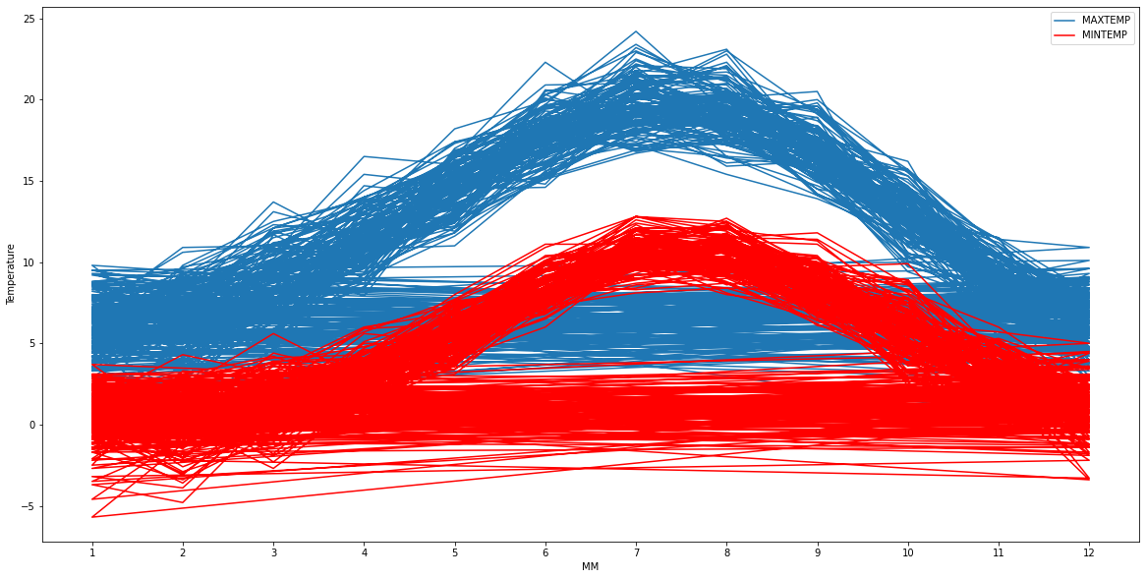

It is evident from the multiple line plots that the month of June has the highest temperature in Durham. The month of January has the lowest temperature in Durham.

We would now use a histogram and a scatter plot to understand the distribution of rainfall received in Durham and the number of air frost days in Durham. We have used these two plots because the histogram would show the distribution of the rainfall received in mm and the number of air frost days would be evident using a scatter plot. The next figure would be a histogram which would show us the Rainfall frequency. The figure is as follows:

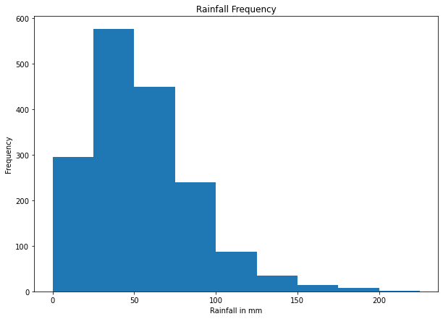

It is evident from the line plot that the maximum frequency of rainfall recorded for all the months in Durham equals 50 mm. The next figure would be a scatter plot which would show us the comparison of air frost days in different months. The figure is as follows:

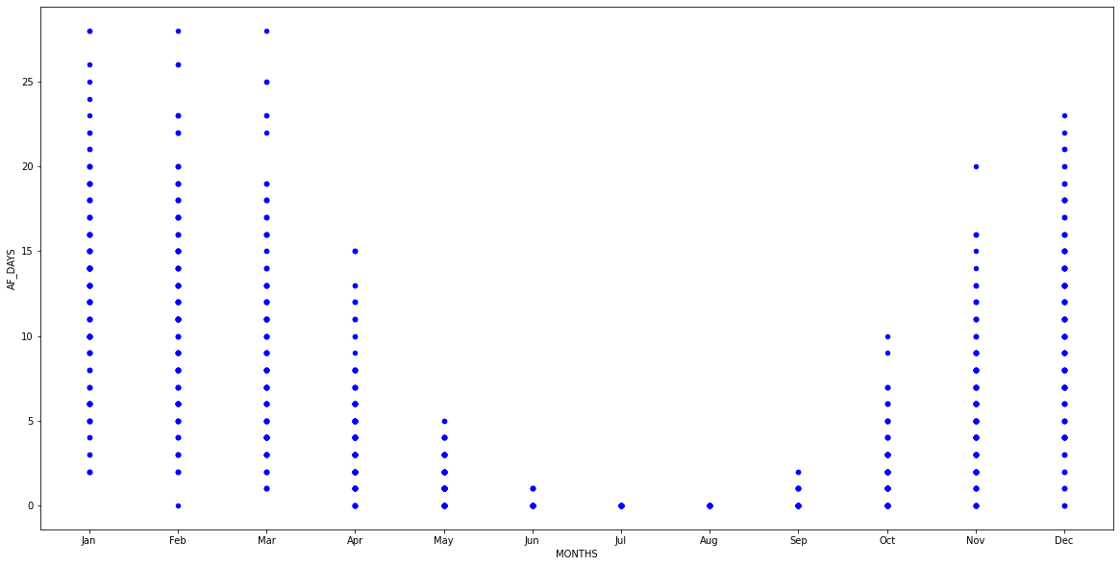

It is evident from the box plot that the month of January, February and March has the highest number of air frost days in Durham. The highest number of air frost days in a month equals 28.

# CONCLUSION

We have analysed the weather of Durham and it is evident that the month of June has the highest temperature and the month of January has the lowest temperature. The rainfall frequency is highest at 50 mm. The month which has the highest number of air frost days in Durham is January followed by February and March. The highest number of air frost days in a month equals 28.

**REFERENCES**

Met Office, 2022. *Historic station data.* [Online]   
Available at: https://www.metoffice.gov.uk/research/climate/maps-and-data/historic-station-data  
[Accessed 12 November 2022].